We are  Moving!  As of May 22nd we will be located  At 25 E. Alger Street, across the street from the Centennial 5 Movie Theater. Feel free to stop by and check out our new clinic.  Same Great Folks and Quality of Care!  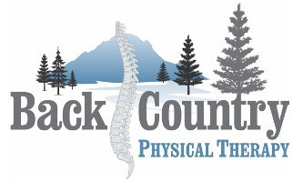 | Back Country Physical Therapy is committed to providing you with the most effective, evidence and outcome based practice is Sheridan, WY and surrounding areas. You will find compassion, honesty, integrity, humor and trust in your therapist as they strive to get you better. You will be seen by one therapist from the beginning to end of your treatment to ensure 100% continuity of care because you deserve nothing less. The measure of our success will be found in the trust we build with the community we serve.  Back Country Physical therapy  25 E. Alger St.  Sheridan, WY 82801  307-461-9669  Backcountrypt.com  Hours: Monday-Thursday  7 A.M.- 5 P.M

